Faculty of Computing



**[Computer Communications & Network]**

**Lab No 2 Tasks (Network Devices)**

**Lab Instructor: Ma’am Hafsah Mahmood**

**NAME: HUDA TAYYAB**

**SAPID:35483**

**Task 1: Write down the advantages and disadvantages of RJ45 connectors.**

|  |  |
| --- | --- |
| **Advantages** | **Disadvantages** |
| 1. Widely used and compatible with most networking devices. | 1. The plastic clip can be fragile and break easily, potentially leading to connection issues. |
| 1. Simple to connect and disconnect. | **2.Limited Distance, i**magine talking to someone on a string phone—it only works if you’re close enough. |
| 1. Provides stable and secure connections. | **3.**Unshielded versions can be affected by electromagnetic interference (EMI), which can degrade network performance. |
| 1. Inexpensive compared to other connectors. | **4.**Troubleshooting and replacing faulty connectors or cables can be time-consuming, especially in large installations**.** |

**Task 2: Briefly explain how the data is transmitted in wireless medium**

Here's explanation:

**1. Data Encoding:** Your device turns data into signals that can travel through the air.

**2.Transmission:** These signals are sent out as electromagnetic waves by a transmitter (like a Wi-Fi router).

**3.Propagation:** These electromagnetic waves travel through the air, possibly bouncing off objects.

**4. Reception:** A receiver (like your phone) catches these waves with its antenna.

**5. Data Decoding:** The receiver then converts the waves back into readable data for you.

**Task 3: Briefly explain all type of network topologies.**

**Here’s a explanation for each type of network topology:**

1. **Bus Topology:** All devices share a single central cable for communication.

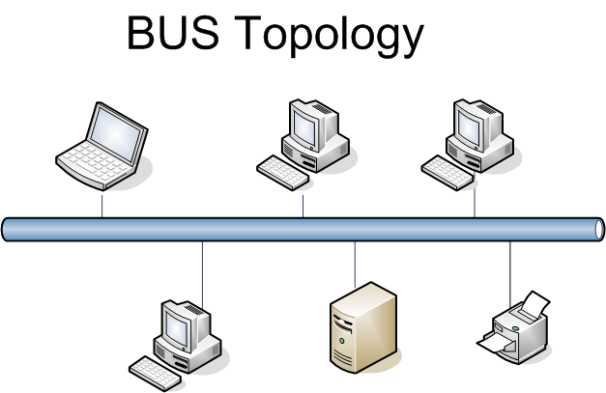

1. **Star Topology:** All devices connect to a central hub or switch.

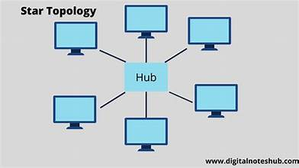

1. **Ring Topology:** Devices are connected in a circular loop, passing data around.

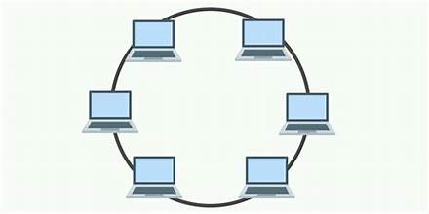

1. **Mesh Topology:** Every device connects directly to every other device, creating multiple paths.

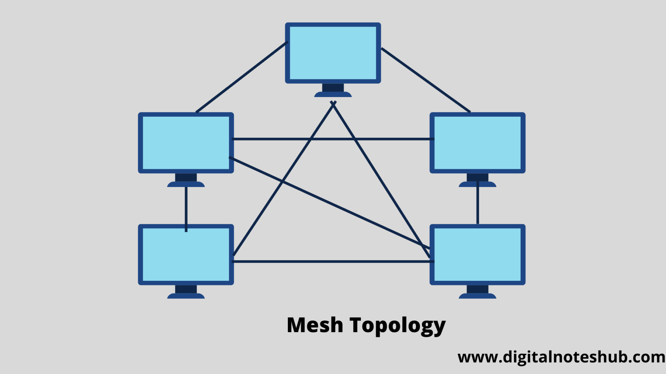

1. **Tree Topology:** A central root node branches out into multiple levels of star networks.

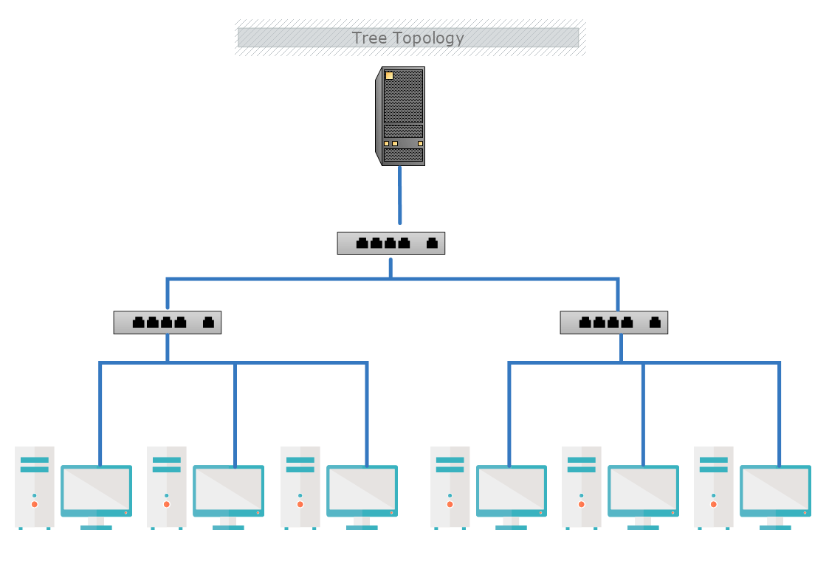

1. **Hybrid Topology:** Combines different topologies to meet specific network needs.

